## 系统架构设计

1.开发视图  
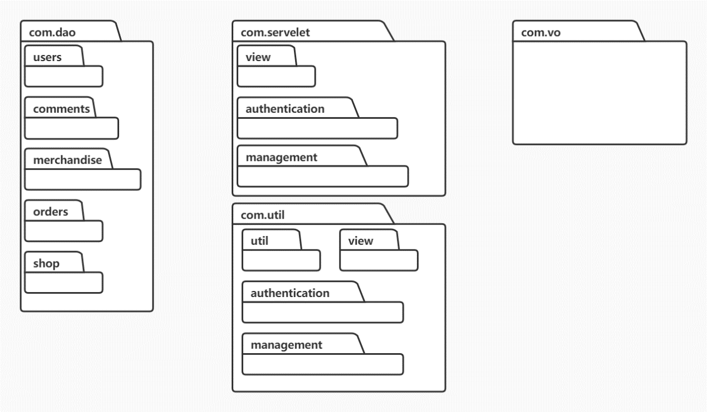

com.dao:

users

comments

merchandise

orders

shop.

**com.util:**

authentication

management

util

view

**com.servlet:**

authentication

management

view

#### 2.数据模型设计



### 数据字典

|  |  |  |  |  |
| --- | --- | --- | --- | --- |
| 表名 | 字段名 | 字段类型 | 字段长度 | 描述 |
| SellerAccount | s_act | String | 10 | 卖家账号 |
| SellerAccount | s_pwd | String | 12 | 卖家密码 |
| SellerAccount | s_status | int | 1 | 买家账号状态 |
|  |  |  |  |  |
| BuyerAccount | b_act | String | 10 | 买家账号 |
| BuyerAccount | b_pwd | String | 12 | 买家密码 |
|  |  |  |  |  |
| Shop | sh_id | int | 10 | 商铺编号 |
| Shop | s_act | String | 10 | 卖家账号 |
|  |  |  |  |  |
| AdminAccount | a_act | String | 10 | 管理员账号 |
| AdminAccount | a_pwd | String | 12 | 管理员密码 |
|  |  |  |  |  |
| Merchandise | m_id | int | 10 | 商品编号 |
| Merchandise | sh_id | int | 10 | 商铺编号 |
| Merchandise | m_name | String | 20 | 商品名称 |
| Merchandise | m_intro | String | TEXT | 商品简介 |
| Merchandise | m_status | int | 1 | 商品状态 |
|  |  |  |  |  |
| MGenre | m_id | int | 10 | 商品编号 |
| MGenre | genre1 | String | 20 | 第一级类别 |
| MGenre | genre2 | String | 20 | 第二级类别 |
|  |  |  |  |  |
| Comments | c_id | int | 10 | 评论编号 |
| Comments | m_id | int | 10 | 商品编号 |
| Comments | b_act | String | 10 | 买家账号 |
| Comments | c_star | int | 1 | 评论星数 |
| Comments | c_content | String | 200 | 评论内容 |
|  |  |  |  |  |
| StockLog | sl_id | int | 10 | 库存编号 |
| StockLog | m_id | int | 10 | 商品编号 |
| StockLog | sl_num | int | 10 | 库存数量 |
| StockLog | sl_date | Date |  | 日期 |
|  |  |  |  |  |
| PriceLog | pl_id | int | 10 | 价格编号 |
| PriceLog | m_id | int | 10 | 商品编号 |
| PriceLog | pl_price | int | 10 | 商品价格 |
| PriceLog | pl_date | Date |  | 日期 |
|  |  |  |  |  |
| Orders | o_id | int | 10 | 订单编号 |
| Orders | m_id | int | 10 | 商品编号 |
| Orders | b_act | String | 10 | 买家账号 |
| Orders | o_status | int | 1 | 订单状态 |
| Orders | o_num | int | 10 | 订单数量 |
|  |  |  |  |  |
| MPicture | pl_id | int | 10 | 图片编号 |
| MPicture | p_ads | String | 10 | 图片地址 |
| MPicture | m_id | int | 10 | 商品编号 |
|  |  |  |  |  |
| BuyerAddress | ba_id | int | 10 | 地址编号 |
| BuyerAddress | b_act | String | 10 | 买家账号 |
| BuyerAddress | b_ads | String | 50 | 买家地址 |
|  |  |  |  |  |
| BuyerInfo | b_act | String | 10 | 买家账号 |
| BuyerInfo | b_tele | int | 12 | 买家电话 |